Abstract

This document guides you how to implement freeboard with few simple steps.

Freeboard Implementation

## 

**Contents**

**Pre-requisite 2**

**Deploy FreeBoard on Local Server 2**

**MQTT 2**

**JSON Websocket Push Datasource 3**

**Time Series (Highcharts) 4**

### **Pre-requisite**

Npm and Node.js need to be installed.

### **Deploy FreeBoard on Local Server**

Firstly, open “Command Prompt” from windows, and go to the directory of freeboard folder. Secondly, install the package by using “npm install”. Lastly, run the FreeBoard with “npm start” command. Now the freeboard can access through the localhost with port 3000.

### **MQTT**

1. Select on “ADD” under “DATASOURCES”;
2. Select “MQTT”;
3. Give a name for this data source;
4. Enter the MQTT topic search string;
5. Enter MQTT server URL;
6. Enter port 443 for secure communication;
7. Select YES for use of encryption;
8. Enter the client id that has been set to the MQTT server;
9. Enter the API Key or Username if required;
10. Enter the API Authentication Token or Password if required;
11. Select YES for JSON Message if the messages on your topic are in JSON format, or select No if not;
12. Click on SAVE.
13. Below is a sample demo for adding an MQTT data source

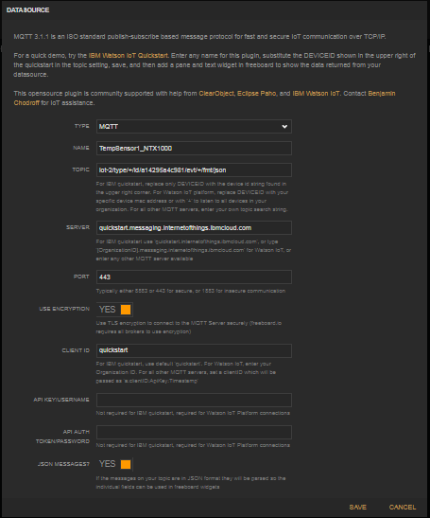

### **JSON Websocket Push Datasource**

1. Select on “ADD” under “DATASOURCES”;
2. Select “JSON Websocket Push DataSource”;
3. Give a name for this data source;
4. Enter WebSocket server URL;
5. Click on SAVE.
6. Below is a sample demo for adding a JSON WebSocket data source

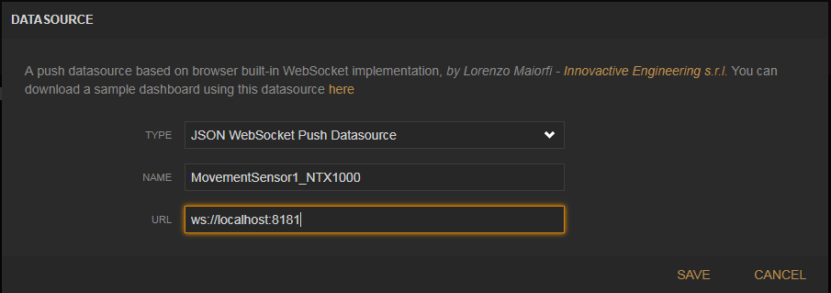

### **Time Series (Highcharts)**

1. Select on “ADD PANE” besides the ARTC logo;
2. Select “Time series (Highcharts)”;
3. Enter the value for time frames;
4. Enter the high of the time series line chart
5. Select the chart type, either Area or Spline;
6. Give a title for the chart;
7. Specify what does x and y-axis represents;
8. Add in the data source for series 1 by click on the “DATASOURCE” besides the column, and give a label to it;
9. If there are more than one type of data, then do the same thing in series 2 and 3;
10. Click on SAVE.
11. Below are sample demos for the highchart.

